**Project Proposal**

**Design and Implementation of Home Security System**

**Submitted By:**

**Md. Ismail Hossain**

Roll: ASH1611040M

**Project Supervisor:**

**Tanvir Zaman Khan**

Lecturer

Information and Communication Engineering



NOAKHALI SCIENCE AND TECHNOLOGY UNIVERSITY

Noakhali-3814, Bangladesh

Submission Date: 17 December, 2018

**DECLARATION**

This project proposal is submitted to the Information and Communication Engineering, Noakhali Science and Technology University, Noakhali for having the B.Sc. in Engg. Degree in ICE. This is also needed to certify that this project is under the B.Sc. in Engg. Course of dept. Of ICE, NSTU titled “ICE-4110: Project and Thesis”. So, I, here by, declare that this project report has not been submitted elsewhere for the requirement of any kind of degree, diploma or publication.

Md. Ismail Hossain

B.Sc. Student of ICE, NSTU

Roll No: ASH1611040M

Session: 2015 - 2016

**ACCEPTANCE**

This project proposal is submitted to the Information and Communication Engineering, Noakhali Science and Technology University, Noakhali.

(Tanvir Zaman Khan)

Lecturer

Information and Communication Engineering

Noakhali Science and Technology University

Sonapur - 3814, Bangladesh

**ABSTRACT**

All over the world, security has been a major concern in every home. Automated security systems are a useful addition to todays home where safety is an important issue. Here, a security system has been developed that uses sensors to detect any security violation and sends out the alert signal by high intensity Buzzer. The purpose of this research is to design a home security system using Zigbee and Arduino controllers with number of sensors. The security system is widely used at home, institutes and factories. Three communication topology type are supported by Zigbee; they are: mesh, star and tree. Zigbee technology is characterized as having a low data rate, low power consumption and low cost. Arduino platform has good specifications, cheap, easy to use and wide varieties of shields have been emerged with many different purposes such as; Ethernet and GSM (Global System for Mobile communications) support available.

This study utilizes motion, gas and temperature sensors as the end device for detecting any intruder, gas or fire. Two Zigbee devices are used; one of them is used as a transmitter and the other as a receiver. Receiver coupled to the Arduino UNO and connected by wire to a computer to show the output using graphical user interface; also, Arduino Uno is connected to a bluetooth module to show the output on a smart phone.

The results show that the designed system can send and receive data up to 100 meters of distance between Zigbee sides (receiver – transmitter). The home security system using Zigbee and Arduino controllers with sensors has been successfully designed and implemented.

**TABLE OF CONTENTS**

|  |  |  |
| --- | --- | --- |
| **Serial No.** | **Name of The Topic** | **Page No.** |
|  |  |  |
| 1. | Introduction | 6-7 |
|  |  |  |
| 2. | Literature Survey | 8-10 |
|  |  |  |
| 3. | Objectives | 11 |
|  |  |  |
| 4. | Design Methodology | 12-16 |
|  |  |  |
| 5. | Project Requirements | 17 |
|  |  |  |
| 6. | Design Prototype | 18-19 |
|  |  |  |
| 7. | Conclusion and Discussion | 20 |
|  |  |  |
| 8. | References | 21 |
|  |  |  |

**1. INTRODUCTION**

Home security is a worldwide concerned issue. The security system has been enhanced through applying various ways, for example, by employing many security officers, using innovative weapons, alarms, control system, producing electronic hardware and software and many more, currently, many studies on smart systems of home have been carried out covering all aspects; for instance, multimedia, lighting, security monitoring, temperature control … etc., in a smart system of home, the tendency is towards the use of an automated system helping users to monitor the situation of home; accordingly, simplifying and accelerating daily works. Hence, the effects of human errors can be avoided by utilizing automatic systems and then saving electricity

The advantages of using Zigbee & Arduino controllers providing low data rate transmission, low energy consumption, ease in setting up the network and low costs together with smaller sensor size. Zigbee is the most widely deployed enhancement to the IEEE 802.15.4 standard where the organization maintains, supports, and develops more protocols for advanced applications in defining additional communication features. The enhancements consist of authentication with valid nodes, encryption for security and data routing that allows mesh networking. With Zigbee, all nodes are able to communicate with each other and can be handled by a single Zigbee, wirelessly. Zigbee devices are restricted through a rate of 250 Kbps that make it suitable for low data rate transmission. Zigbee has many advantages; for example, its battery can stay up to few months depending on applications, making it perfect for install and forget devices such as small household systems. Arduino is an open-source platform used for building electronics projects. Arduino consists of both a physical programmable circuit board (often referred to as a microcontroller) and a piece of software, or IDE (Integrated Development Environment) that runs on your computer, used to write and upload computer code to the physical board. This paper presents the development and implementation of a low cost system for home security using two type of controllers (Zigbee & Arduino) and microcontroller development board connected with three sensors, buzzers, display unit, Bluetooth devices and GUI (Graphical User Interface). The system proposed is analyzed in terms of detectable range and results to prove that the system is able to work perfectly for indoor environments and up to 100 meters of distance between the transmitter and the receiver. The rest of this paper is organized as follows; section 2 describes the methodology and approach, software and hardware configuration and the experiment setup of the home security system using (Zigbee & Arduino),

**1.1 Statement of Problem:**

The system of security monitoring involves data transmission system, fast receiving data and accurate at a certain distance to facilitate placing devices freely at significant locations for the receiver of data display. This means that this system has to be transportable and used easily. Concerning display system, it should be straight forward and understandable enabling users to take important immediate action. The system should not be hacked by any person, regardless of different ways comprising: on input source power, data transmission content, receiving data content and the location of main processor of security sensor device . Also, there is a number of important characteristics that must be contained in this system, including: resistance to water and high temperature and durable to avoid failure of transmission and receiving processes of data. There are some problems exist in several security systems concerning the use of sensor devices. Limitations in the security system will be caused by these problems. Inevitably, extensive use of sensors is required for home security system due to their importance in security systems. Sensors should be sensitive to human motion and working on the most appropriate range, i.e., not too close or too far, to detect movement. In addition, they must be consistent with the human nature. According to this situation, a new intelligent household monitoring system designed in this research. Several high-precision wireless sensor terminal nodes are adopted with Zigbee protocol. On the basis of “Open System Interconnection (OSI) model”, Zigbee protocol had been developed and built on “IEEE standard 802.15.4” which defines “the physical and Medium Access Control (MAC) layers”. Operation of Zigbee wireless device requires very-low power consumption making it the most preferable wireless device to be used in Wireless Sensor Network (WSN). Zigbee has multi-hop capability of communication; therefore, it provides an unlimited communication range.

**1.2 Limitations of the Existing System:**

Most of earlier systems have used star topology. This topology consists of a central node to which all other nodes are connected. But if the central node fails then the entire system is affected.The remote station of monitoring is represented by GUI, while the controlling device is represented by microcontroller. Though monitoring and controlling of devices can be done remotely from any part of the world wherever Internet access is available, additional cost is incurred by this system because of computer requirement.Supplier dependency due to the need of using separate systems for different appliances of companies.

**2. LITERATURE SURVEY**

**1. Bluetooth based home automation system using cell phones:**

In Bluetooth based home automation system the home appliances are connected to the Arduino BT board at input output ports using relay. The program of Arduino BT board is based on high level interactive C language of microcontrollers; the connection is made via Bluetooth. The password protection is provided so only authorized user is allowed to access the appliances. The Bluetooth connection is established between Arduino BT board and phone for wireless communication. In this system the python script is used and it can install on any of the Symbian OS environment, it is portable. One circuit is designed and implemented for receiving the feedback from the phone, which indicate the status of the device.

**2. Zigbee based home automation system using cell phones:**

To monitor and control the home appliances the system is designed and implemented using Zigbee. The device performance is record and store by network coordinators. For this the Wi-Fi network is used, which uses the four switch port standard wireless ADSL modern router. The network SSID and security Wi-Fi parameter are preconfigured. The message for security purpose first process by the virtual home algorithm and when it is declared safe it is re-encrypted and forward to the real network device of the home. Over Zigbee network, Zigbee controller sent messages to the end. The safety and security of all messages that are received by the virtual home algorithm. To reduce the expense of the system and the intrusiveness of respective installation of the system Zigbee communication is helpful.

**3. GSM based home automation system using cell phones:**

Because of the mobile phone and GSM technology, the GSM based home automation is lure to research. The SMS based home automation, GPRS based home automation and dual tone multi frequency (DTMF) based home automation, these options we considered mainly for communication in GSM. In figure shows the logical diagram the work of A. Alheraish, it shows how the home sensors and devices interact with the home network and communicates through GSM and SIM (subscriber identity module). The system use transducer which convert machine function into electrical signals which goes into microcontroller. The sensors of system convert the physical qualities like sound, temperature and humidity into some other quantity like voltage.

The microcontroller analysis all signal and convert them into command to understand by GSM module. Select appropriate communication method among SMS, GPRS and DTFC based on the command which received GSM module.

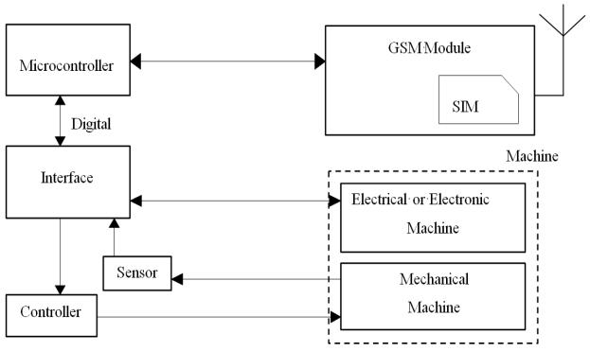

**Figure.** Mobile-based home automation from the work of A. Alheraish

**4. Wi-Fi based home automation system using cell phones:**

Wi-Fi based home automation system mainly consist three modules, the server, the hardware interface module, and the software package. The server is connected to the internet, so remote users can access server web based application through the internet using compatible web browser. Software of the latest home automation system is split to server application software, and Microcontroller (Arduino) firmware. The Arduino software, built using C language, using IDE comes with the microcontroller itself. Arduino software is culpable for gathering events from connected sensors, then applies action to actuators and pre-programed in the server. Another job is to report and record the history in the server DB. The server application software package for the proposed home automation system is a web based application built using asp.net. The server application software can be accessed from internal network or from internet if the server has real IP on the internet using any internet navigator supports asp.net technology. Server application software is culpable of maintain the whole home automation system, setup, configuration. Server use database to keep log of home automation system components, we choose to use XML files to save system log.

**5. Home automation using RF module:**

The important goal of Home Automation System is to build a home automation system using a RF controlled remote. Now technology is accelerating so homes are also getting smarter. Modern homes are deliberately relocating from current l switches to centralil system, containing RF controlled switches. Today traditional wall switches situated in various parts of the home makes it laborious t for the end user to go near them to control and operate. Even further ON/OFF signals to the receiver where devices are connected by operating the stated remote switch on the transmitter, the loads can be turned ON/OFF globally using wireless technology.

**6. Home automation using Android ADK:**

It turns into more problematic for the old persons or physically handicapped people to do so. Home Automation using remote implements an easier solution with RF technology. In order to accomplish this, a RF remote is combined to the microcontroller on transmitter side that sends

The devices of home are associate to the ADK and the Connection is established between the Android device and ADK. The devices of house are link to the input/output ports of the board (EMBEDDED SYSTEM) and their current situation will have passed to the ADK. The microcontroller board (Arduino ADK) is based on the ATmega2560. It has a USB host connection to associate with Android based phones, and that is based on the MAX3421e IC.

**7. Cloud Based home automation system:**

Home Automation using cloud based system focuses on design and implementation of home gateway to collect data about data from home appliances and then send to the cloud-based data server to get store on Hadoop Distributed File System, it is process using Map Reduce and use to implement a monitoring tasks to Remote user Presently home Automation System is persistently developing its resilience by assimilating the current characteristics which gratify the rising interest of the people

**8. Raspberry pie home automation with wireless sensors using smart phone**

Home Automation System has been developed with Raspberry Pi by reading the algorithm and frequency) using home automation, the call tariff is a big demerit, which is not the problem in their proposed method. In Home Automation using web server, the design of web server and the memory space required is dismiss by this method, because it just uses the already established web server service given by G-mail. LEDs were used to identify the switching action. This System is efficient and flexible interactive

**Sending Commands to the Raspberry Pi**

The script running on server side of our laptop or on a web server receives the input commands from the user and appropriately sends it to the client (Raspberry Pi). In this, we will be using those input commands to turn a light ON/OFF. When we give the command to turn ON a light by the server side script, the data and information gets relayed to the Raspberry Pi and its GPIO pin will turns ON a relay. The system can send current updates to the server to detect whether the light is ON/OFF. Using PIR motion sensor we can send the data signal to the Raspberry Pi, we just run a script which can reads the sensor by a GPIO pin and transmit the data to overall system through the IoTF platform. This can then be look by the IoTF console.

**9. Wireless Home Automation system using IoT**

This system uses mobiles or computers to control basic home control and function automatically through internet from anywhere around the world globally, an automated home is sometimes called a smart home. It is meant to save the electric power and human energy. The proposed system is a distributed home automation system, consists of server i.e. Wi-Fi module, sensors. Server controls and monitors the various sensors, and can be easily configured to handle more hardware interface module (sensors). The Arduino board, with built in Wi-Fi module acts as web server. Automation System can be accessed from the web browser of any local PC using server IP, or remotely from any PC or mobile handheld device connected to the internet with appropriate web browser through server real IP (internet IP). Wi-Fi technology is selected to be the network infrastructure that connects server and the sensors. Wi-Fi is chosen to improve system security (by using secure Wi-Fi connection), and to increase system mobility and scalability.

**3. OBJECTIVES**

The main objective of the home security system is to introduce the system to the user to monitor the safety of their homes from burglary. In addition, to introduce the system using Microcontroller and Sensors to control and monitor all of the houses**.** This is objectives of the project will be implemented:

* To Design and Implement a effective home security system.
* To implement a low-cost home security system.
* To design home security system using Zigbee and Arduino Microcontroller with Sensors.
* To find suitable circuit and electronic component to build that system.
* To know how the operation of circuit home security system.
* To prove how that system can be used in the house.

**4. DESIGN METHODOLOGY**

This research comprises two parts, namely hardware and software. The implementation of hardware requires designing research circuit and the development of a PCB. The implementation of software involves code writing besides programming the “Arduino and Zigbee”. After completing both parts, the next process is to test and debug the system. A WSN standard is used to connect all components. When the sensor detects any change it sends a signal to the controller (Arduino Mega) which analyzes this signal and transmits it to the second controller (Arduino Uno) wirelessly using Zigbee. After that, the Arduino Uno transmits the data to the GUI.

**.1 Hardware Implementation**

In this section discusses the design and function of components connected to Arduino for constructing the security system. Moreover, it describes the process of making the circuitry connection between microcontroller and components.

**4.1.1 Hardware Circuit**

* **PIR Sensor**

The PIR (Passive Infrared) sensors allow you to sense motion, almost always used to detect whether a human has moved in or out of the sensors range. They are small, inexpensive, low-power, easy to use and don't wear out. For that reason they are commonly found in appliances and gadgets used in homes or businesses. They are often referred to as "Pyroelectric", or "IR motion" sensors. PIR are basically made of a Pyroelectric sensor, which can detect levels of infrared radiation. Everything emits some low level radiation, and the hotter something is, the more radiation is emitted. The sensor in a motion detector is actually split in two halves. The PIR sensor itself has two slots in it, each slot is made of a special material that is sensitive to IR. The lens used here is not really doing much and so we see that the two slots can 'see' out past some distance (basically the sensitivity of the sensor). When the sensor is idle, both slots detect the same amount of IR, the ambient amount radiated from the room or walls or outdoors. When a warm body like a human or animal passes by, it first intercepts one half of the PIR sensor, which causes a positive differential change between the two halves. When the warm body leaves the sensing area, the reverse happens, whereby the sensor generates a negative differential change. These change pulses are what is detected, as shown in Fig.

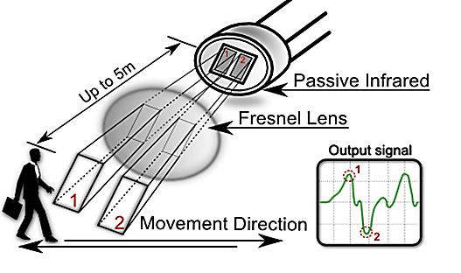

**Fig:** How PIR Sensor Work

PIR sensor circuit diagram is shown in Fig. This sensor has three pins, they are: “reference voltage pin (VCC)”, “ground pin (GND)” and the “output voltage pin”. Connect pin (VCC) with 5V, ground to ground and connect the output to a digital input pin.

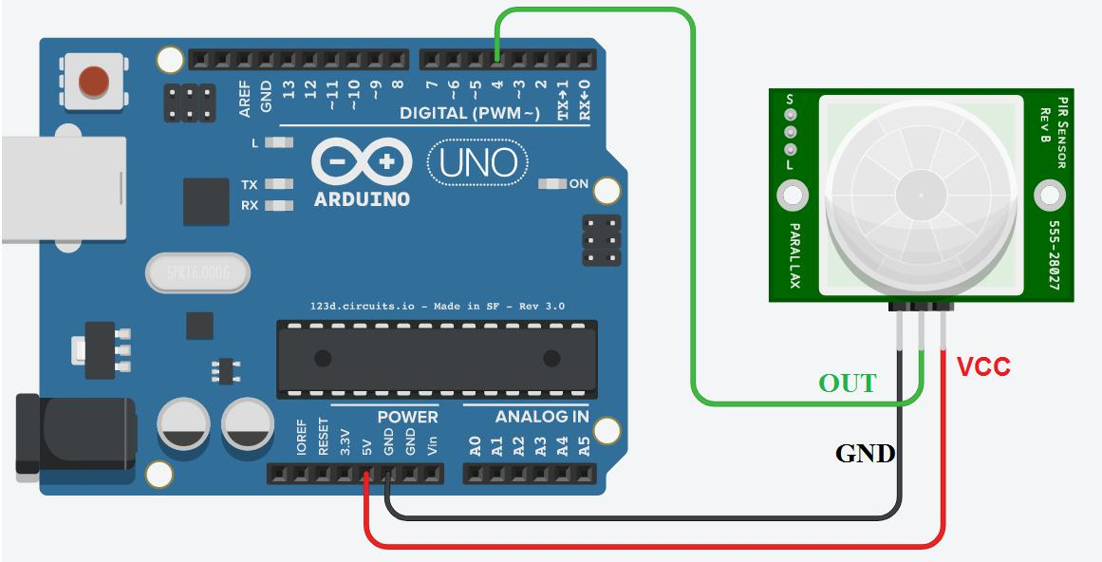

**Fig:** Circuit Diagram for PIR Sensor.

* **Gas Sensor:**

Electrochemical gas sensors are gas detectors that measure the concentration of a target gas

by oxidizing or reducing the target gas at an electrode and measuring the resulting current. The sensors contain two or three electrodes, occasionally four, in contact with an electrolyte. The electrodes are typically fabricated by fixing a high surface area precious metal on to the porous hydrophobic membrane. The working electrode contacts both the electrolyte and the ambient air to be monitored usually via a porous membrane. The electrolyte most commonly used is a mineral acid, but organic electrolytes are also used for some sensors. The electrodes and housing are usually in a plastic housing which contains a gas entry hole for the gas and electrical contacts.

* [**NTC Thermistor Sensor:**](http://www.te.com/global-en/products/sensors/temperature-sensors/ntc-thermistor-sensors.html)

NTC stands for (Negative Temperature Coefficient). NTC thermistors are resistors with a

negative temperature coefficient, which means that the resistance decreases with increasing temperature. They are primarily used as resistive temperature sensors and current-limiting devices. The temperature sensitivity coefficient is about five times greater than that of silicon temperature sensors and about ten times greater than those of resistance temperature detectors (RTDs). NTC sensors are typically used in a range from −55°C to 200°C. The non-linearity of the relationship between resistance and temperature exhibited by NTC resistors posed a great challenge when using analog circuits to accurately measure temperature, but rapid development of digital circuits solved that problem enabling computation of precise values by interpolating lookup tables or by solving equations which approximate a typical NTC curve.

**Buzzer:**

Buzzer is an audio signaling device. The typical uses of buzzers are for alarms, timers and

confirmation of user input such as a mouse click or keystroke. The project used an electronic type of buzzer which is a piezoelectric element that driven by an Arduino microcontroller signals.

**4.2 The development of Circuit Board:**

This research utilized donut board. Before connecting all components on the board, and for the purpose of ensuring the functional connection between each component, bread board was used in this research. Donut board was not connected to each hole as in the strip board. For making the connection, solder method was employed to connect all components. The development circuit diagram is shown in Fig.

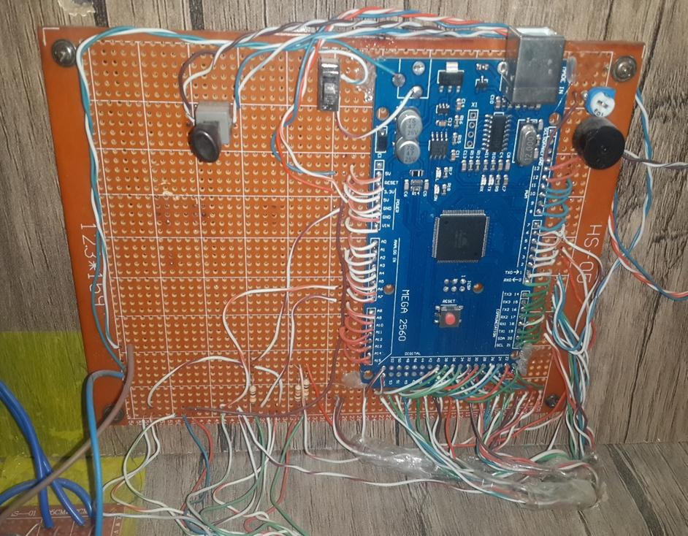

.

**Fig:** The Development Circuit Diagram

**4.3 Hex Keypad:**

Hex key pad is essentially a collection of 16 keys arranged in the form of a 4×4 matrix. Hex key pad usually have keys representing numeric 0 to 9 and characters A to F. The hex keypad has 8 communication lines namely R1, R2, R3, R4, C1, C2, C3 and C4. R1 to R4 represents the four rows and C1 to C4 represents the four columns. When a particular key is pressed the corresponding row and column to which the terminals of the key are connected gets shorted. For example if key 1 is pressed row R1 and column C1 gets shorted and so on. The program identifies which key is pressed by a method known as column scanning. In this method a particular row is kept low (other rows are kept high) and the columns are checked for low. If a particular column is found low then that means that the key connected between that column and the corresponding row (the row that is kept low) is been pressed. For example if row R1 is initially kept low and column C1 is found low during scanning, that means key 1 is pressed. The simplified diagram of a typical hex keypad is shown in Fig.

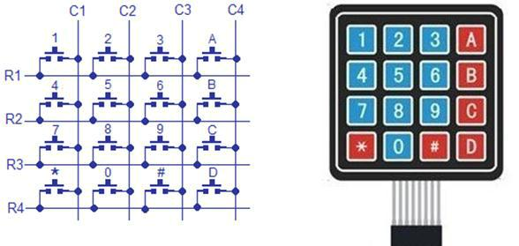

**Fig:** Hex Keypad.

**4.4 Bluetooth Module:**

Bluetooth is a standardized protocol for sending and receiving data via a 2.4 GHz wireless link. It’s a perfect for short-range, wireless transmissions between electronic devices.

**4.5 Software Implementation:**

This section discusses the methodology to interface the sensor and hardware module. The most significant part is to enable the analog sensor to send analog data to Arduino, and then to transfer data to the GUI.

**4.5 Programming of Arduino:**

Programming of Arduino is the core of current research because Arduino controls all the data from sensors to the GUI and alarm system. [Arduino programming language](https://www.arduino.cc/en/Reference/HomePage) (based on [Wiring),](http://wiring.org.co/) and [the Arduino Software (IDE)](https://www.arduino.cc/en/Main/Software) “Integrated Development Environment”, based on [processing.](https://processing.org/) Processing is an open source computer programming language and IDE. Processing is built for new media art, the electronic arts, and visual design communities for teaching computer programming fundamentals in a visual context, and to function as the foundation for electronic sketchbooks. Java language is the basis of processing language.

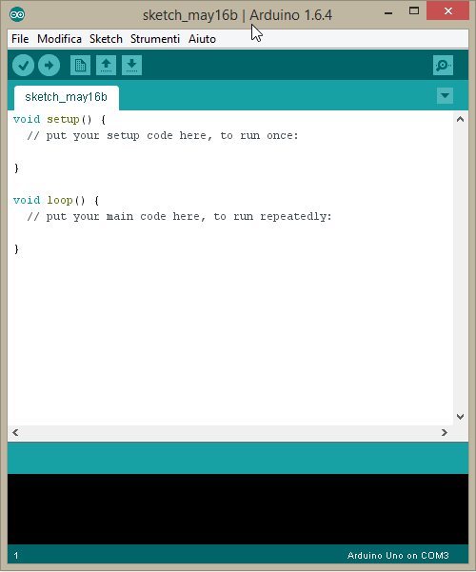

**Fig: Figure 5: Arduino IDE Fig: Arduino IDE**

**4.6 Zigbee Programming:**

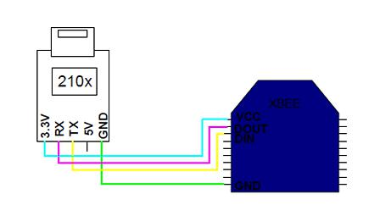Zigbee connection diagram is shown in Fig. To have successful transference of data from Arduino, both Zigbee transmitter and receiver should be set up with the programming. In order to read the port, “driver microchip 210x for USB port” should be installed in the computer. Then, “XCTU software” is required to run the programming with Zigbee.

**Fig:** Zigbee Connection to USB Port.

**4.7 Zigbee Programming:**

The XCTU software is installed and executed in the computer, each COM for each Zigbee must be tested by clicking on the button Test/Query as shown in Fig. XCTU software is support for programming and configuring Zigbee, WI-FI modules

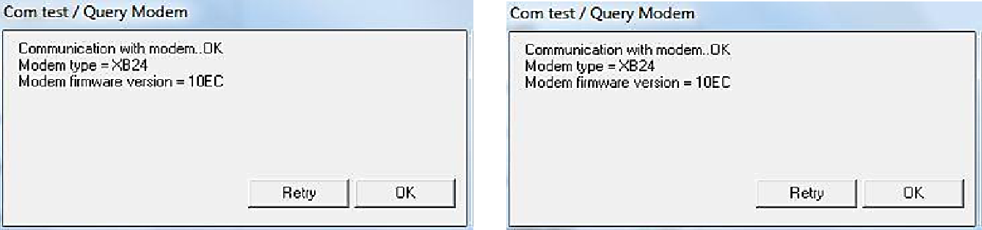

**Fig:** Test the COM of Zigbee.

**5. PROJECT REQUIREMENTS**

**Hardware Requirements:**

* Personal Computer (with Windows 7 ,10 or later or Linux Operating System)
* Arduino microcontroller(Arduino Uno and Arduino Mega)
* Zigbee microcontroller
* Processor (Intel Core i3 or higher)
* Buzzer for audio signaling
* Sensors

**Software Requirements:**

* Arduino Software (IDE)
* XCTU Software for Zigbee Programming

**Languages:**

* Arduino programming language
* Zigbee programming language
* C programming language
* Java programming language

**Other Requirements:**

* Bluetooth Module
* Wifi Module
* Hex keypad

1. **DESIGN PROTOTYPE**

The prototype of the home security system is presented and the performance analyses of the sensors for various distances of the completed home security system using Zigbee & Arduino controllers. As shown Fig, the system consists of two parts as a transmitter side consist of: power supply, hex keypad, two limit switches, TFT LCD, buzzer and three sensors namely, motion detector circuit gas or fire detector and temperature detector, connected to Arduino Mega. Motion, gas and temperature sensors as the end device for detecting any intruder, gas or fire. Two Zigbee devices are used; one of them is used as a transmitter and the other as a receiver. Receiver side consist of a Zigbee coupled to the Arduino UNO and connected by wire to a computer to show the output using graphical user interface; also, Arduino Uno is connected to a Bluetooth module to show the output on a smart phone, which also behave as transmitters.



**Fig:** Experiment Diagram of the Research for Transmitter Side.

When the system is activated and if the window or the door opened or any movement is detected on the motion sensor, an alarm will be triggered to inform the house owner. The responses will be recorded on the GUI. Three types of messages will appear on the personal computer, which are „Window is detected‟, „Door is detected‟ or „Motion is detected‟ depending on the signal received as shown in Fig**.**

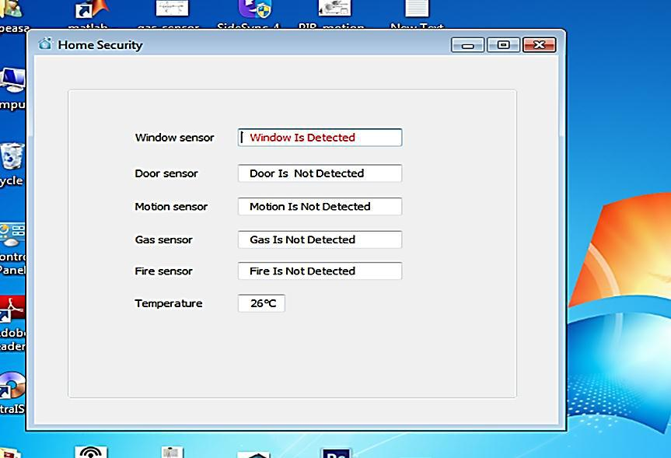

**Fig:** Window Sensor Detected, Door Sensor Detected or Motion Sensor Detected.

1. **CONCLUSION AND DISCUSSION**

**Discussion:**

Four different types of sensors are:

* Successfully used together without any missing/losing of data/information to sense the most important situations/status, especially in small place/area like kitchen at home or any location requires security systems by using Zigbee standard wireless communication without using any wire and between transmitter and receiver sides.
* With distance range cover about 100 meters.
* Without any interference with other radio signals.
* This means that the proposed system is characterized with low cost.
* Less power.
* With best security.

But other previous models/kits have used only one or two types of sensor, or its model/kit might be made separately, each model for a specific situation/status. Some have used RF like Wi-Fi or Bluetooth, while others have used wired systems.

**Conclusion:**

The implementation of Home Security System using Zigbee & Arduino standards with Sensors is done successfully. The communication is properly done without any interference between different modules in the design. It is found that the implemented design in this study

provides portability. In addition, data transmission is performed with low power consumption. By using .NET technology, the sensor information is read successfully from serial port, operations are performed, and the information is displayed in the GUI.

**References:**

1. Mohammad Syuhaimi, Ab-Rahman and Mohd Ariff Razaly **"*A Review of Security System*** ***for Smart Home Applications*"**, Journal of Computer Science, 8(7), 1165 (2012).
2. Norlezah Hashim, Mohd Amir Hafifi Abdul Razak and Fakrulradzi Idris, **"*Home Security*** ***System Using Zigbee*"**, Journal Teknologi (Sciences and Engineering), 74(10), 29 (2015).
3. Nidhi Patel, Hiren Kathiriya and Arjav Bavarva, **"*Wireless Sensor Network Using Zigbee*"**, International Journal of Research in Engineering and Technology, 2(6), 1038 (2013).
4. Dr. Subhi R. M. Zeebaree and Hajar M. Yasin, **"*Arduino Based Remote Controlling for*** ***Home: Power Saving, Security and Protection*"**,International Journal of Scientific &Engineering Research, 5(8), 2229 (2014).
5. Subhankar Chattoraj, **"*Smart Home Automation based on different sensors and Arduino*** ***as the master controller*"**, International Journal of Scientific and Research Publications,5(10), 1 (2015).
6. Fei Ding Guangming, Song Jianqing Li and Aiguo Song, **"*Remote Measuring and Control*** ***Key Lab of Jiangsu Province*"**, School of Instrument Science and Engineering SoutheastUniversity, China, IEEE Conf., 1566, 40 (2009).
7. Gutierrez, Jose .A, **"*Wireless Medium Access Control (MAC) and Physical Layer (PHY)***

***Specifications for Low-Rate Wireless Personal Area Networks (LR-WPANs)* "**, 1stEd.,The Institute of Electrical and Electronics Engineers, New York, USA (2003).

1. Ajinkya Kumar Jadhav and Snehal Gaherwar, **"*Development of Wireless Ordering System*** ***for Hotel*"**, Certified Journal, 5(1), 2250 (2015).
2. Zipporah Tarus, **"*PIR Sensor Based Security System*",** Bachelor of Engineering Thesis, University of Applied Sciences, Helsinki Metropolia, (2017).

**10.**https://www.arduino.cc/en/Guide/Introduction.